

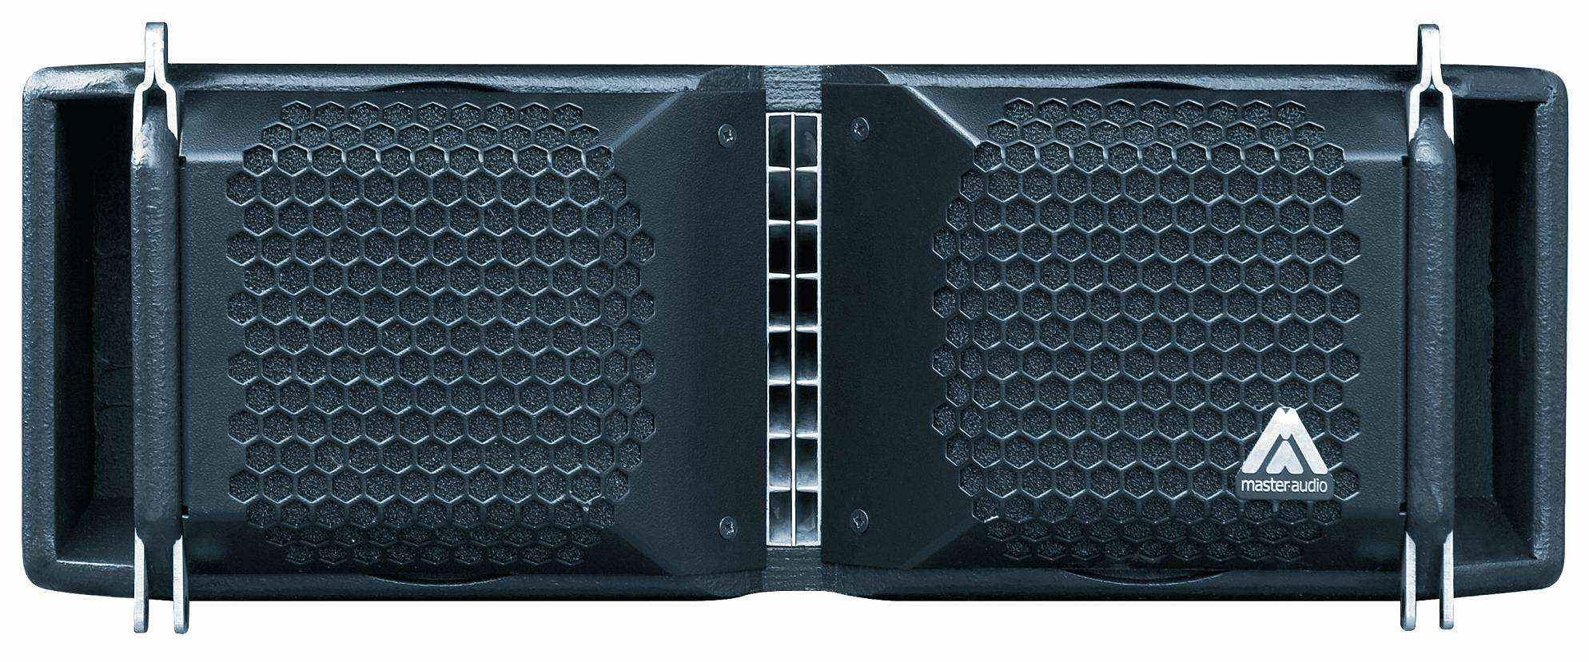
Architectural and engineering specifications

MA206A & MA206P

• The 2-way full range loudspeaker system shall have two direct radiating neodymium magnet 6,5-inch low frequency transducers and one 1.7-inch voice coil diameter, 1-inch exit , titanium diaphragm compression driver coupled to a planar waveguide. Low frequency transducers shall be rated at a nominal impedance of 8 ohms each one. Compression driver shall be rated at a nominal impedance of 16 ohms.

• Enclosure shall be bass-reflex type.

• The usable bandwidth shall be 105Hz to 18kHz (-10dB). When operating with the low frequency extension cabinets useful bandwidth can be extended down to 38Hz (MAW115D) and 32Hz (MAW215D2K).

• The planar transducer configuration shall generate a polar pattern coverage of 90º horizontally with symmetric pattern control across the projection axis. In line source mode, the system shall be curved up to a maximum of 8º for each element without breaking the inter-element acoustic coupling.

• Maximum SPL peak, measured at 1m under free field conditions shall be 123dB.

• Enclosure cabinet construction shall consist of Baltic birch plywood. Dimensions shall be 516,5 mm (20,3 inch) wide, 199 mm (7,8 inch) high at the front, 98 mm (3,8 inch) high at the rear, 493,5 mm (19,4 inch) deep. Enclosure weight shall be 17 Kg (MA206D) and 13Kg (MA206P). The front enclosure shall be protected by two steel grilles with acoustically transparent foam. The enclosure shall include internal hardware for rigging and shall be used in conjunction with dedicated rigging accessories.

• The amplifier shall be built inside the cabinet, consisting of two channels, with a total power of 1000W/4Ohm for the low frequency channel and 500W/4Ohm for the high frequency channel. The amplifier shall be Class D with switching power supply. The amplifier’s power supply shall be capable of protecting itself in case of excessive voltage at the mains. The built-in amplifier of the active model (MA206A) shall be capable of feeding three slave cabinets (MA206P).

• The DSP controller shall be built inside the cabinet and integrated to the power amplifier. The internal DSP architecture shall be 48-bit fixed point, featuring 2nd order IIR biquad filters. Analog-to-Digital converters shall have more than 112dB signal-to-noise ratio, 24-bit word size and shall work at 48kHz sampling rate. The controller shall contain up to 24 presets combining factory and user-defined. The presets shall be visible and selectable by the user at the cabinet’s rear panel (with built-in LCD and keypad).

• The communications protocol shall be RS485, operating at 9600bps with wired connection. The protocol shall support up to 64 elements in daisy-chain and/or hybrid topology. The connection shall be made through an RJ45 port at the cabinet rear panel, using the USBPORT communication kit.

• The control and monitoring software shall be capable of selecting different EQ presets for each cabinet, adding up to 5 parametric EQ or filters and control gain and mute per channel, delay and polarity. The software shall be capable of monitoring the connection status.

• The loudspeaker system shall be the Master Audio® MA MA-206.
• The low-end extension shall be the Master Audio® MA MAW115 or MAW215D2K.
• The rigging accessories shall be the Master Audio® TA-206 and/or the FA10/6 .
• The stacking accessory shall be the Master Audio® FA-15/6.
• The communication kit should be the Master Audio® USB-PORT.
• The DSP control software should be the Master Audio® DSPController.

